# Homework 2: Mastering the Basics of SQL Server

(**Task 1: 5 points**) Complete Task #2 through Task #4 while placing your sql files in Queries. Show in a screenshot that your Homework 2 project in Solution Explorer contains **three** sql files in **Solution Explorer**.

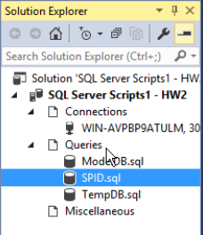

**(Task 2: 5 points**) Show in a screenshot that **DatabaseLog_test** table is created in **MyCISDB2**, and **not** in **MyCISDB1**.

(**Task 3: 4 points**) Create the three temp tables listed above and show their existence using the SELECT command above. Attach a screenshot.

(**Question: 1 points**) When do we use temporary Tables? List two scenarios. When do we use table variable over temp table?

* When wanting to store data temporarily
* When wanting to get filtered subset of a database. Like a snapshot of a larger database.

(**Task 4: 5 points**) Fill in **all** the blanks. Keep in mind that you have made a connection via a dynamic port not the default number. Your answers to the second column must be consistent with the connection you made.

|  |  |  |
| --- | --- | --- |
|  | **Name/Number** | **Description (definition)** |
| SPID | 55 | Server Process ID – Unique sessions in a SQL Server |
| SID | 010500000000000000150000007C98BDF441F8B4DD1677D940F401 | Server Level ID Number |
| principal_id | 259 | Identifies a secure login to the server |
| net_library | TCP/IP | The protocol being used |
| local_tcp_port | 3000 | The port the host is using to connect to the server |

In addition, show the result of each of the four queries in a screenshot.

